**Shading correction using rolling ball background subtraction :**

→ The rolling-ball algorithm estimates the background intensity of a grayscale image in case of uneven exposure. It is frequently used in biomedical image processing.

→ The algorithm works as a filter and is quite intuitive.

→ Microscope images acquired under non-uniform illumination condition make it challenging , sometimes impossible , to extract information via thresholding and segmentation . These images can be corrected using rolling ball background subtraction.

**(1) Read our image :**

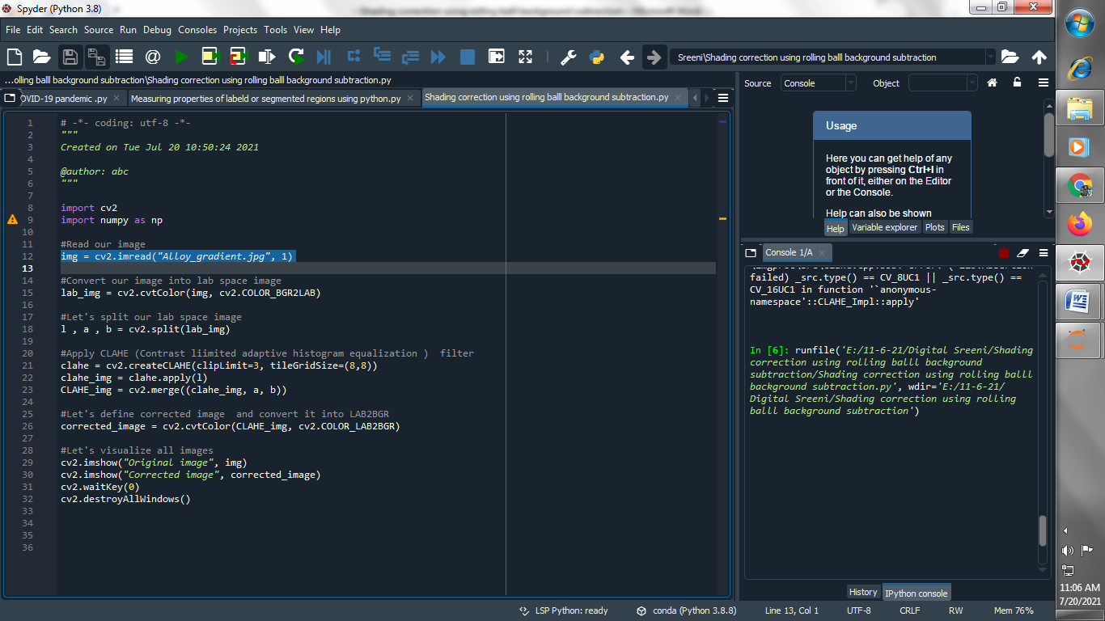

**(2) Convert our image into lab space :**

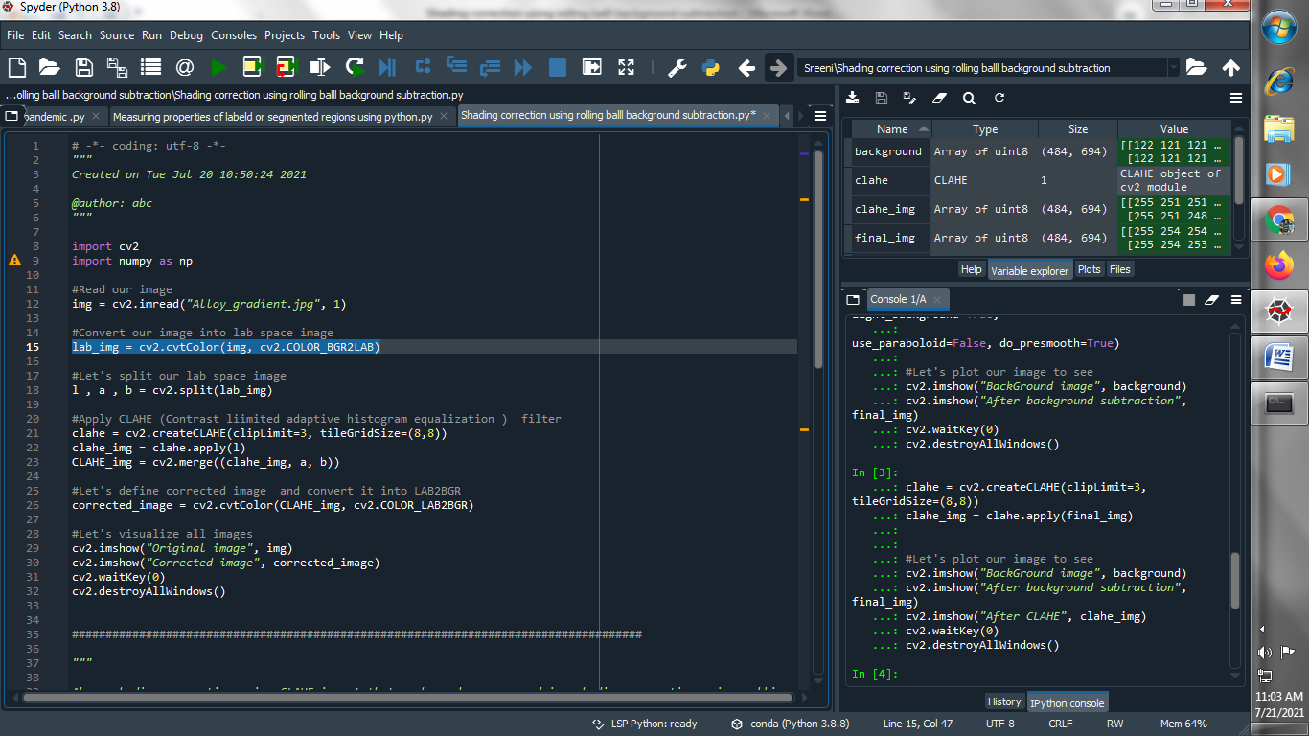

**(3) Let's split our lab space image :**

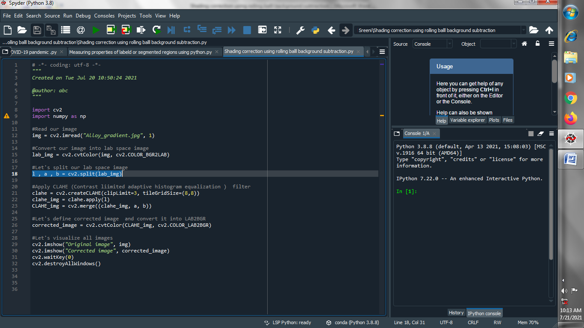

**(4) Apply CLAHE (Contrast limited adaptive histogram equalization ) filter :**

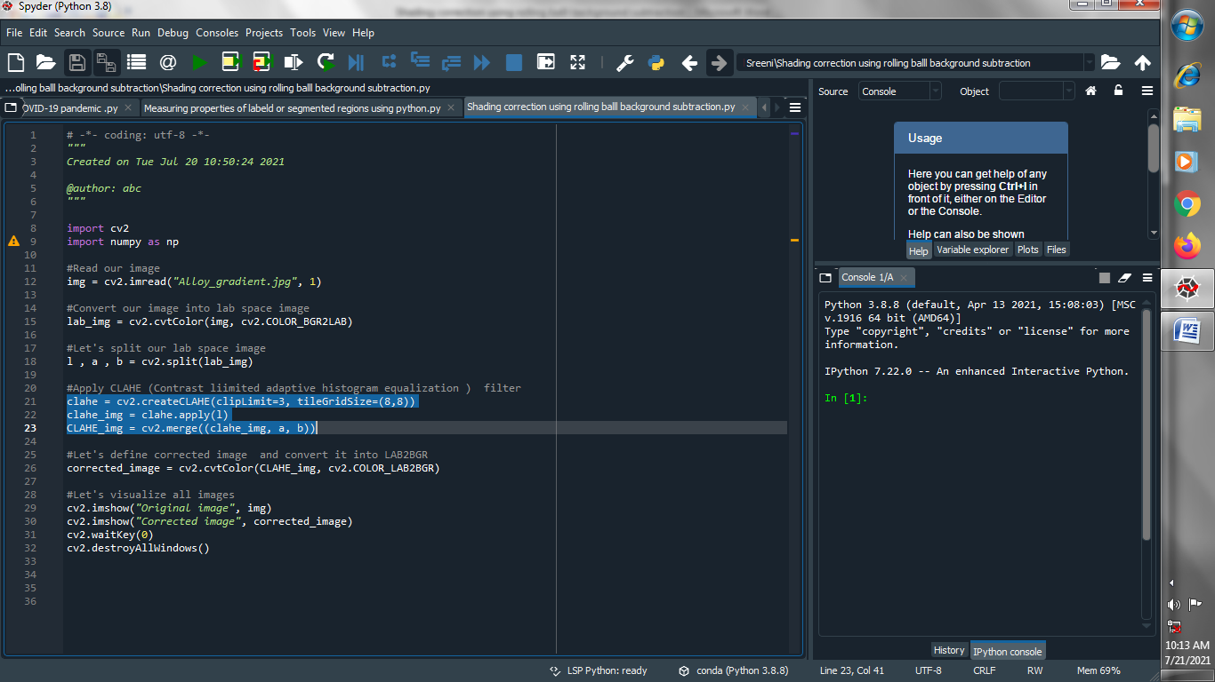

**(5) Let's define corrected image and convert it into LAB2BGR :**

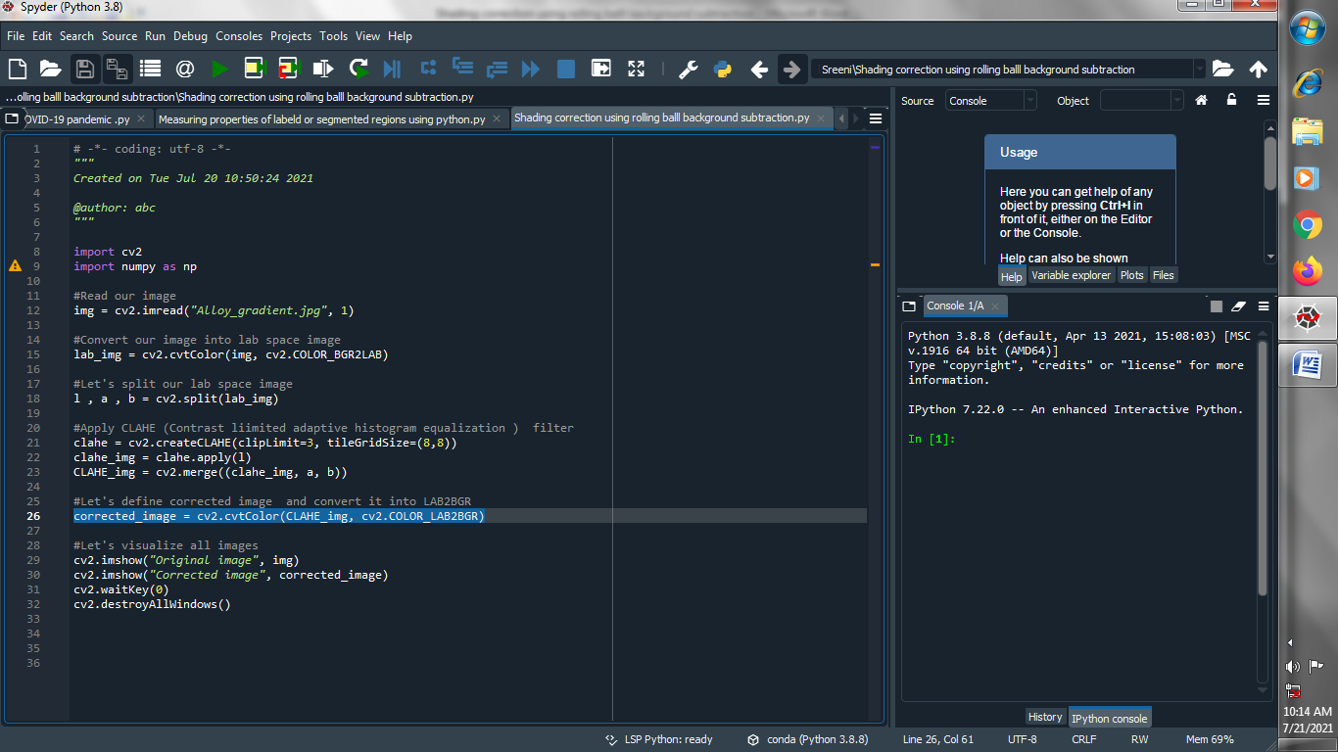

**(6) Let's visualize all images :**

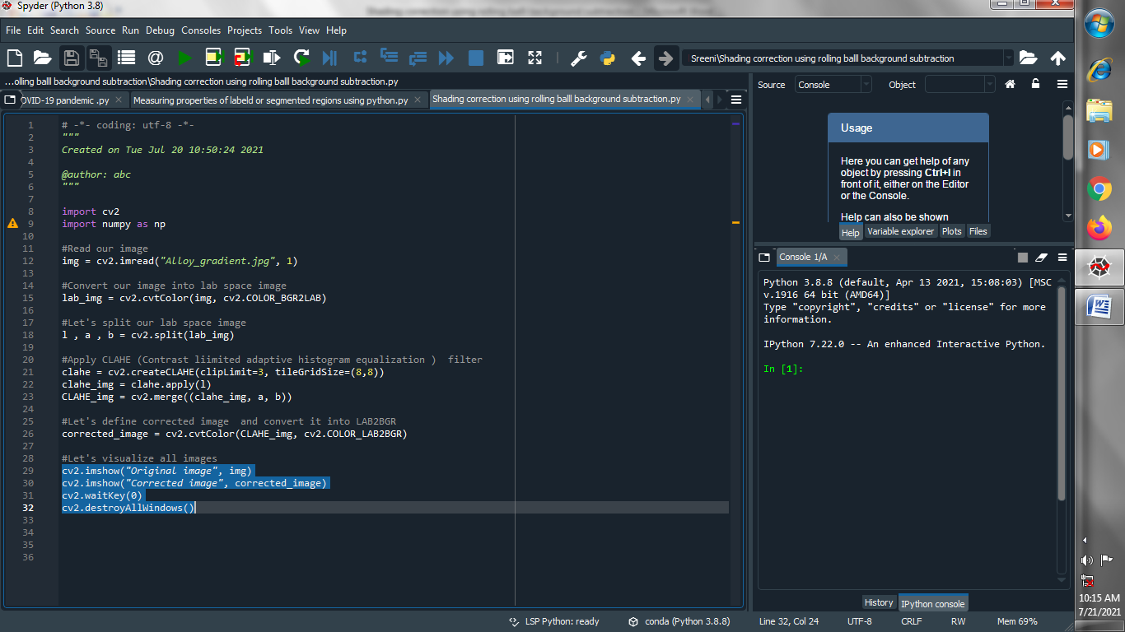

**Output :**

**Original image :**

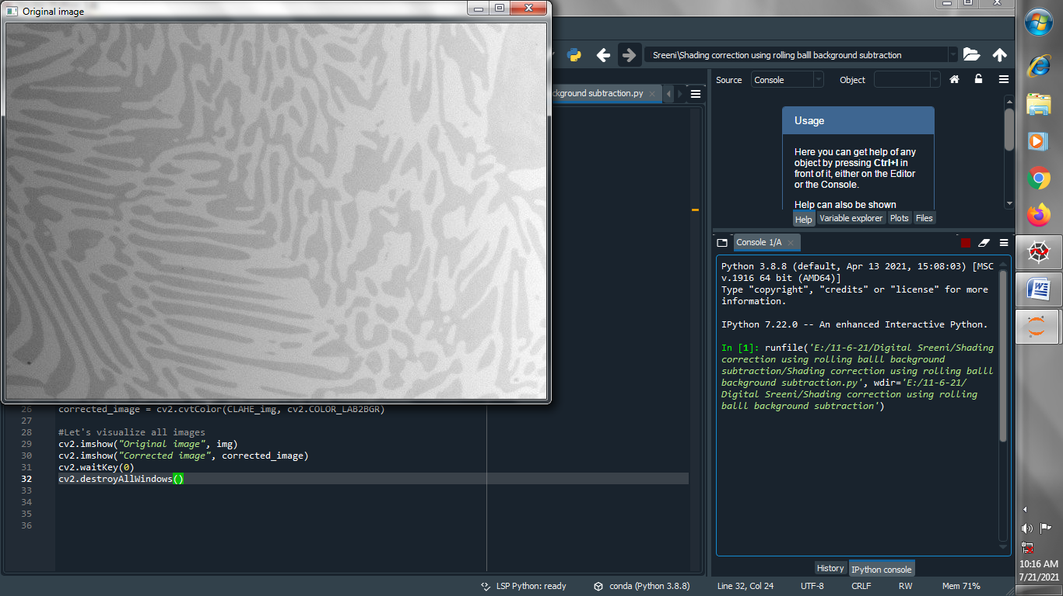

**Corrected image :**

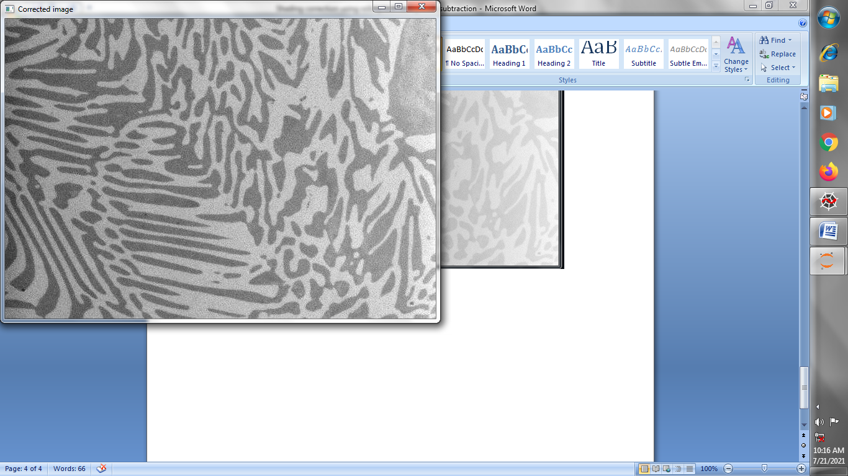

**→ Above shading correction using CLAHE is not that much good so now we doing shading correction using rolling ball background subtraction :**

**(1) Read our image :**

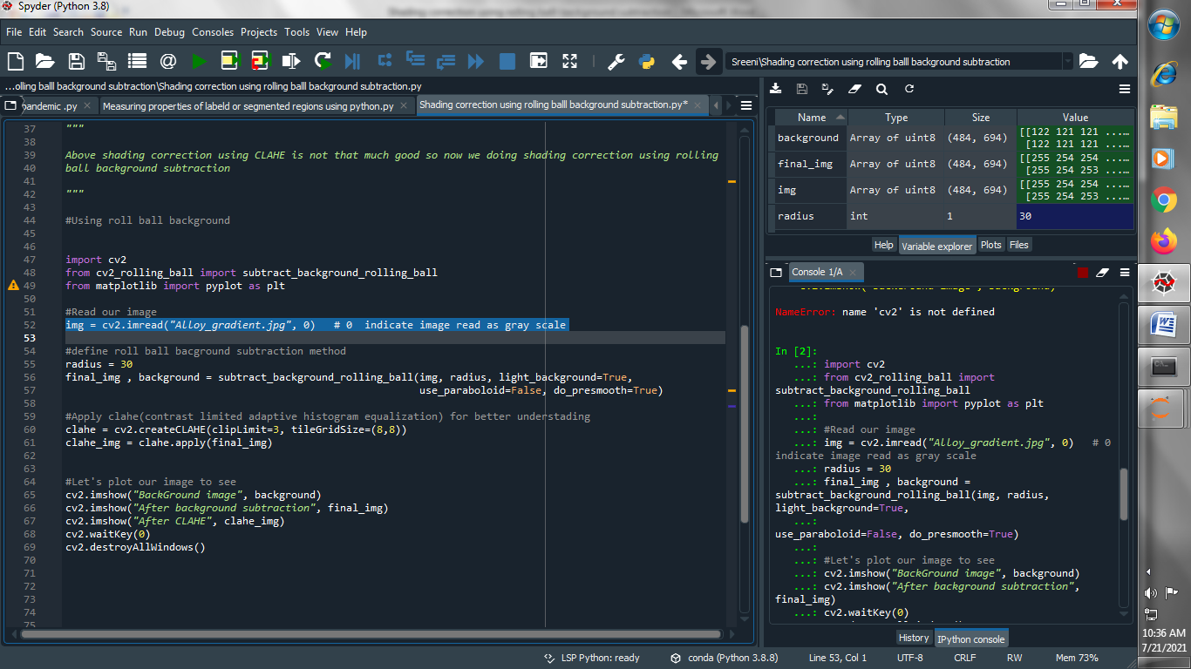

**(2) define roll ball background subtraction method :**

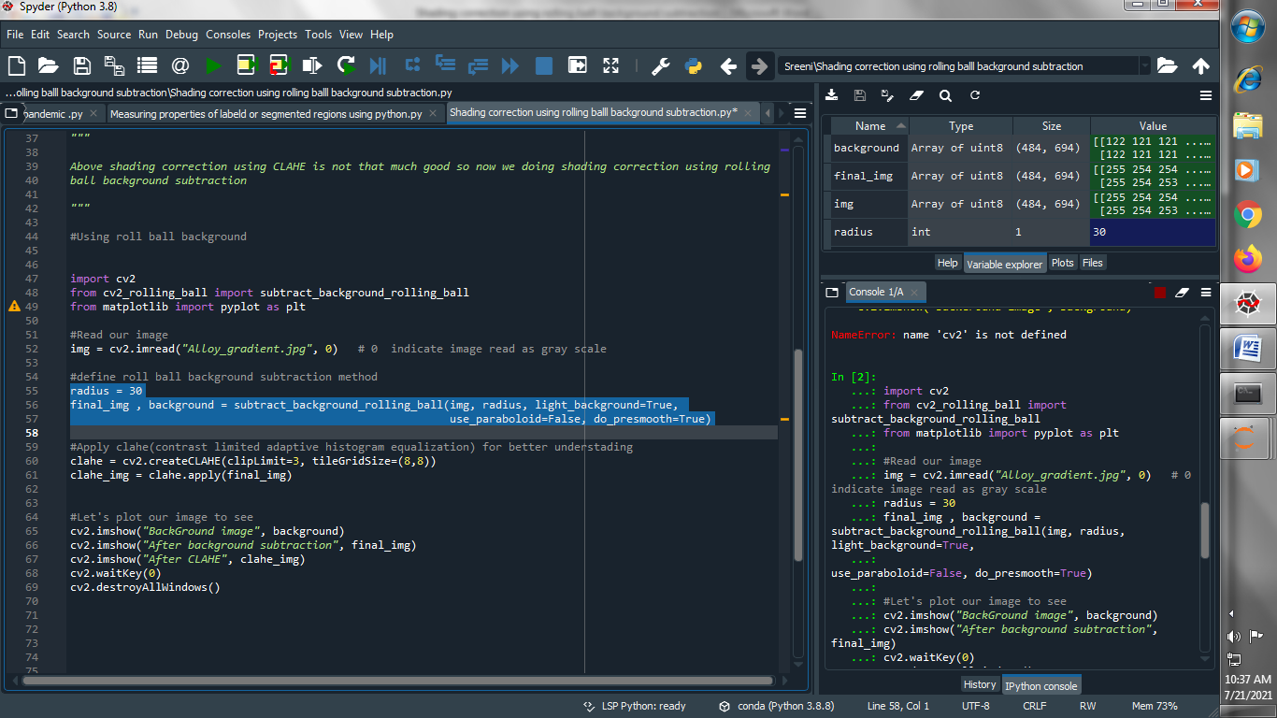

**(3) Apply clahe(contrast limited adaptive histogram equalization) for better understanding :**

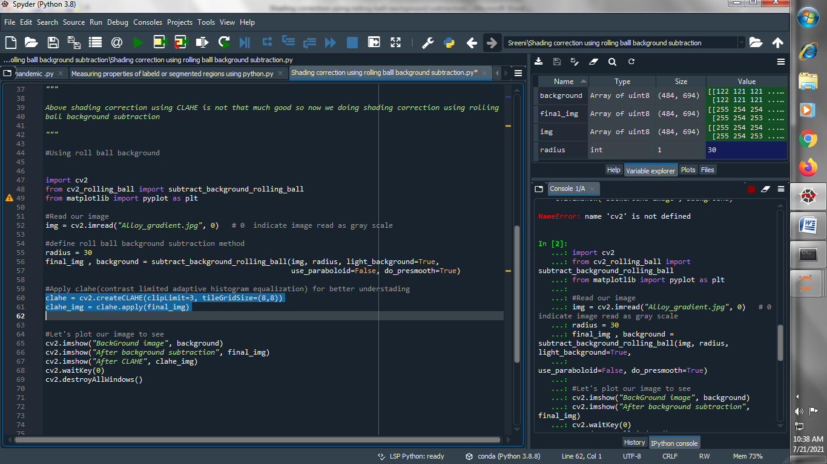

**(4) Let's plot our image to see :**

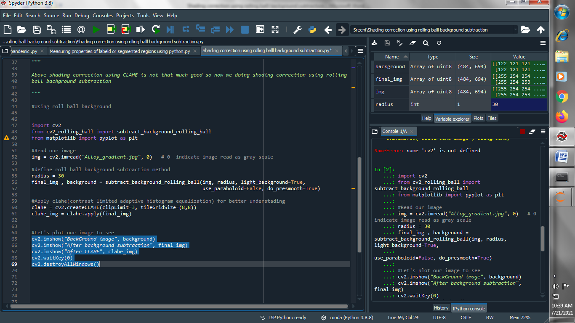

**Output :**

**Background image :**

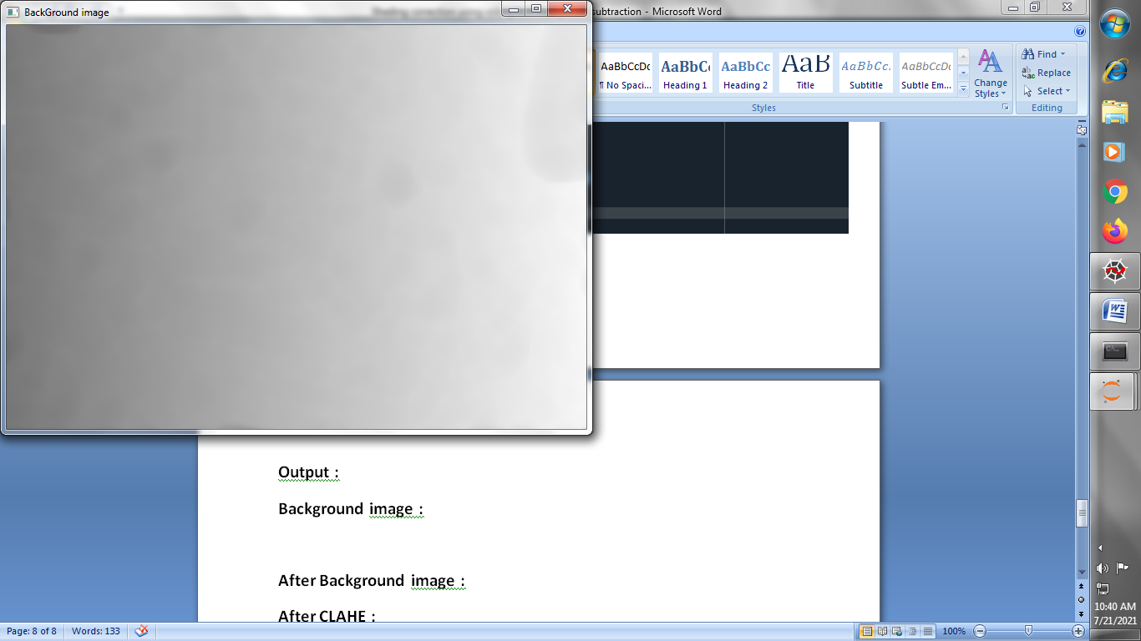

**After Background subtractions :**

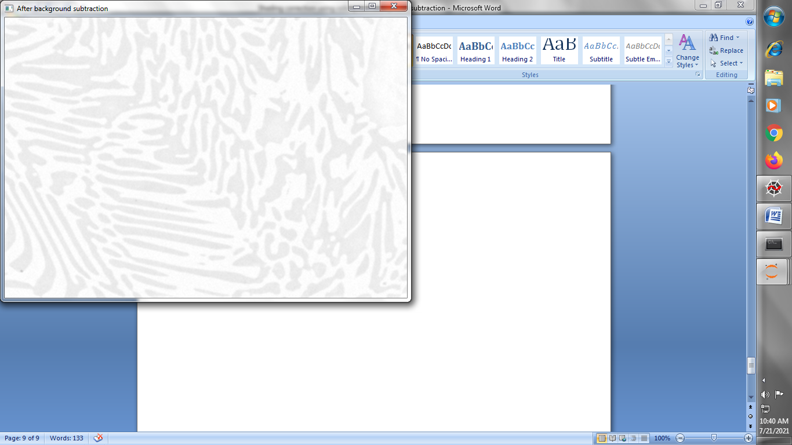

**After CLAHE :**

